TOPOPHILIA DESCRIPTION OF LOVE OF A PLACE
By (Name)
Department/University
Course Code/Name
City/State
Instructor's Name
Due Date

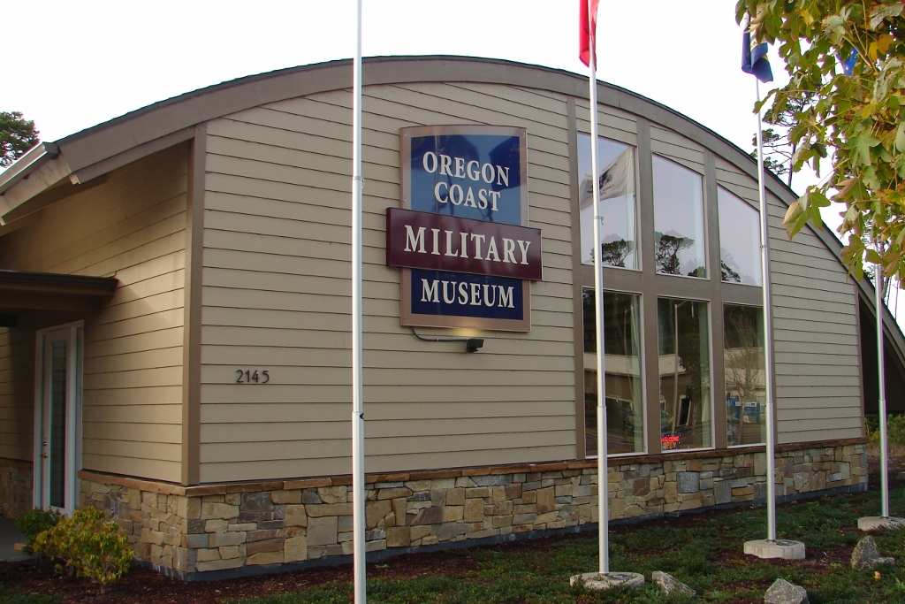
Visit Oregon Coast Military Museum on your trip to Florence. Inspirock.com. (2021). Retrieved 2 October 2021, from https://www.inspirock.com/united-states/florence/oregon-coast-military-museum-a8314398587.

The Oregon Coast Military Museum, a 501c3 non-benefit, opened its entryways in Florence, on the Oregon coast, on July fourth, 2015, following a seven-year exertion by local people to construct a gallery to respect the over 20% of Florence-region occupants who are Veterans. Planned to respect all times of legacy of military and its discipline assist, it is a little exhibition hall in contrast with other galleries in military in USA. The square foot of 3000 show the area is loaded up with life-sized lifelike models portraying scenes from WWI to Vietnam, in addition to a scaled lifelike model of a commonplace Iraqi town depicting a US military caravan going through ("Welcome To The People’S Coast - Oregon Coast Visitors Association").
While little by gallery guidelines, this office is jam-loaded with ancient rarities, keepsakes, and encounters all with an end goal to the museum in preserving its central goal "To Honor our Veterans by Educating Our Public." notwithstanding a bit shop with gift, the Museum likewise includes a little auditorium indicating military narratives, a loaning library and a USO Canteen.
Arranged on Kingwood Street nearby the Florence Municipal Airport, it is always open Thursday to Saturday 10-4. Make sure to see this site while you're venturing to every part of the Oregon coast. Oregon Coast Military Museum is only one of the many features you can orchestrate to see utilizing our online schedule maker.
As a kid, individuals will consistently recollect specific objections that stick with them that established a decent connection. I have a spot that not just established a proper relationship, and it transformed me. It made me think of every one of the things individuals underestimate; places, individuals, initiate. However, this spot got all the unusual things life to one area where I can appreciate them all simultaneously. The Oregon coasts. It was going there as a child was consistently unique. It was getting up promptly in the morning of day while enjoying the drive on the long outing there, passing through woodlands, valleys, and urban communities. The Oregon coast is an exceptionally a spot to depict which is also expensive, yet in actuality, all the people in the town has the same vibe though different environment. Pacific City is little and calm with an extraordinary
It's chilly, breezy, and bright all simultaneously. The seashore extends for a significant distance appearing to be interminable until it arrives at a tall bluff with waves. The sun radiates down on the dampness noticeable all around, making a "shining" effect of adding to the view. In certain spots on the coast, goliath rock arrangements stick out of the water, creating an inquiry on how they are shaped there. Walking on the seashore with sand all over your toes is and maybe not a concern to someone is perhaps the best inclination. In case you stroll in the evening or in the morning hours, you will notice a low tides and you can realize sand dollars and extraordinary shells. Lovely houses and inns line the seashore, all with a similar wilted look they all endeavor to have, and galleries on each spot to catch the view. This objective is a particularly significant spot to Oregonians since it's a particularly magical place. It transports you into an alternate measurement where there could be no different spots like it. You can't be on the seashore without a grin all over, and it's close to difficult to be feeling melancholy when there. Primarily mysterious because you can escape there with loved ones with numerous chances to attempt to encounter new or customary things. Like having a fire on a seashore cooking s'mores with loved ones or trying strange ocean animals at an eatery. The Oregon Coast will consistently hold a spot significant to me. I can hardly wait for another visit. This is my all-time best place.

BIBLIOGRAPHY

"Welcome To The People’S Coast - Oregon Coast Visitors Association." Oregon Coast Visitors Association, 2021, https://visittheoregoncoast.com/.

